Motivator Coaching Guide

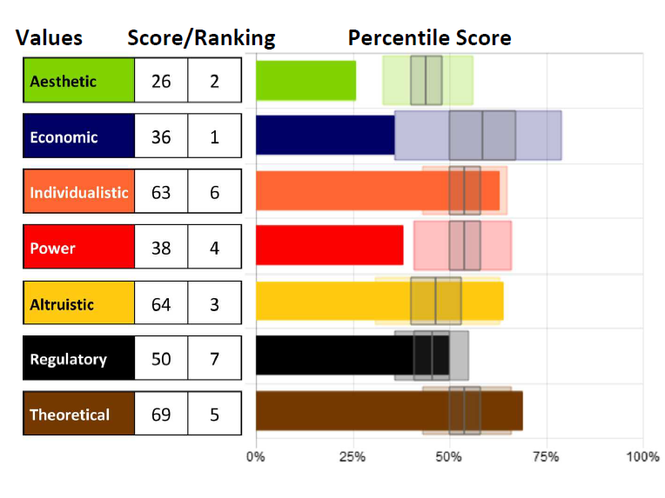
Understanding what
motivates us, what
inspires us, and is
deemed important by us
is a vital first step in self-
awareness and
improving human
performance and
effectiveness.
Knowing our specific
level of motivation can
be crucial to helping us
understand what drives
our beliefs and actions
so we can bring them
into alignment.

Use open-ended and purposeful follow-up questions to uncover
opportunities and reveal areas support is needed. Discuss:

- What are the motivators that are furthest from the mean/norm score? What do those motivators indicate?
- Are there any conflicting motivators or supporting motivators?
What do those motivators indicate?
- What are the primary drivers for this person?
- How do those drivers show up for them? What behaviors do you see that link to those drivers?
- What awareness do they have about their AES, ECO, IND, etc. scores?
  - Are those scores accurate and reflective of their mindset?
  - How do those motivators and that mindset influence their choices and behaviors?
  - Are their behaviors reflecting their wants accurately? If not, why not and should something be done to align them closer?
Action Planning and Coaching

  - Evaluate highest area of desire for adapting and adjusting to be more effective.

  - Suggest improvement ideas and build a clear action plan to address any challenges or struggles. Use the “Continual Improvement Insights” section for the appropriate motivators for some coaching ideas.
  - Discuss how they will be accountable (self-accountability, accountability partner, coach).

How can I support my own development (or my clients and customers) with these suggestions, prompts, and questions?

Assessments 24x7 LLC 5927 Balfour Court, Ste. 103 Carlsbad, California 92008 USA (206) 400-6647

